Write a Stored Procedure namely proc_Grade for the categorization of student. If marks scored by students in examination is <=1500 and marks>=990 then student will be placed in distinction category if marks scored are between 989 and900 category is first class, if marks899and 825 category is Higher Second Class.

Write a PL/SQLblock to use procedure created with above requirement.

Stud_Marks(name, total_marks)

Result(Roll,Name, Class)

**PL/SQL Block: -**

CREATE TABLE stud_marks (name VARCHAR2(20), total_marks NUMBER(5));

CREATE TABLE Result ( roll_no NUMBER(3), name VARCHAR2(20), class VARCHAR2(20) );

INSERT INTO stud_marks (name, total_marks) VALUES ('Khushal', 995);

INSERT INTO stud_marks (name, total_marks) VALUES ('Yash', 865);

INSERT INTO stud_marks (name, total_marks) VALUES ('Tejas', 920);

INSERT INTO stud_marks (name, total_marks) VALUES ('Aayush', 1000);

INSERT INTO stud_marks (name, total_marks) VALUES ('Soham', 745);

SELECT * FROM stud_marks;

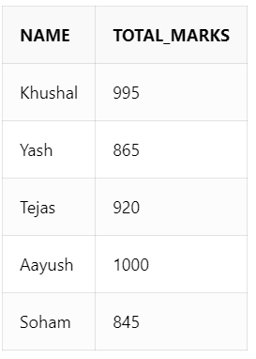

INSERT INTO Result (roll_no, name) VALUES (1, 'Khushal');

INSERT INTO Result (roll_no, name) VALUES (2, 'Yash');

INSERT INTO Result (roll_no, name) VALUES (3, 'Tejas');

INSERT INTO Result (roll_no, name) VALUES (4, 'Aayush');

INSERT INTO Result (roll_no, name) VALUES (5, 'Soham');

CREATE OR REPLACE PROCEDURE proc_Grade (

r IN NUMBER,

grade OUT VARCHAR2,

student_name OUT VARCHAR2

)

IS

m NUMBER(4);

BEGIN

SELECT name, total_marks INTO student_name, m FROM stud_marks WHERE name = (SELECT name FROM Result WHERE roll_no = r);

IF m BETWEEN 990 AND 1500 THEN

grade := 'Distinction';

UPDATE Result SET Class = 'Distinction' WHERE roll_no = r;

ELSIF m BETWEEN 900 AND 989 THEN

grade := 'FirstClass';

UPDATE Result SET Class = 'FirstClass' WHERE roll_no = r;

ELSIF m BETWEEN 825 AND 899 THEN

grade := 'SecondClass';

UPDATE Result SET Class = 'SecondClass' WHERE roll_no = r;

ELSE

grade := '--';

UPDATE Result SET Class = '--' WHERE roll_no = r;

END IF;

END;

/

SELECT * FROM Result;

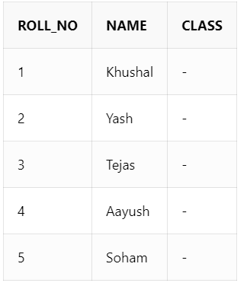

DECLARE

v_grade VARCHAR2(25);

v_name VARCHAR2(20);

BEGIN

proc_Grade(1, v_grade, v_name);

proc_Grade(2, v_grade, v_name);

proc_Grade(3, v_grade, v_name);

proc_Grade(4, v_grade, v_name);

proc_Grade(5, v_grade, v_name);

END;

/

SELECT * FROM Result;

